DATABASE MANAGEMENT SYSTEM:

PROGRAM NO.1
Install and set up MySQL. Create a database and a table to store employee details. Perform basic operations like INSERT & DELETE.
##CREATE DATABASE EmployeeDB;
USE EmployeeDB;
drop table Employee;
CREATE TABLE Employee (
EmployeeID INT PRIMARY KEY AUTO_INCREMENT,
Name VARCHAR(100) NOT NULL,
Salary DECIMAL(10, 2),
JoiningDate DATE,
ActiveStatus BOOLEAN
);
INSERT INTO Employee (Name, Salary, JoiningDate, ActiveStatus)
VALUES
(‘Sarthak Sandhan’, 55000.00, '2023-06-15', TRUE),
(‘Ravindra kalhapure’, 72000.50, '2022-09-25', TRUE),
('Mark Smith', 48000.75, '2021-12-10', FALSE),
('Emily Davis', 63000.00, '2020-07-05', TRUE);
DELETE FROM Employee
WHERE Name = 'John Doe';
DELETE FROM Employee;
SELECT * FROM Employee;

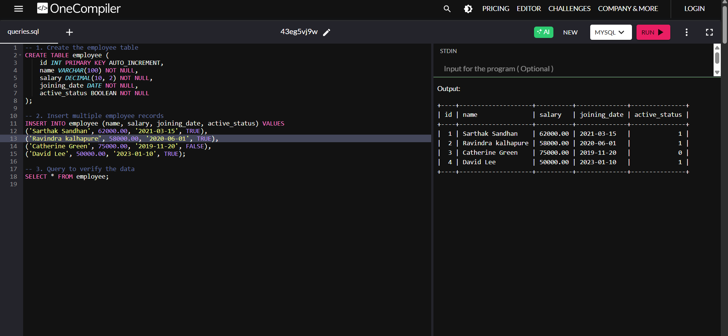

PROGRAM NO.02
Create a table for storing student information. Insert sample data and perform basic operations: INSERT, UPDATE, DELETE, and SELECT.
CREATE TABLE Students (
StudentID INT PRIMARY KEY,
FirstName VARCHAR(50),
LastName VARCHAR(50),
Age INT,
Major VARCHAR(50)
);
INSERT INTO Students (StudentID, FirstName, LastName, Age, Major)
VALUES
(1, 'Aarav', 'Patel', 20, 'Computer Science'),
(2, 'Ishita', 'Sharma', 22, 'Mathematics'),
(3, 'Rohan', 'Mehta', 19, 'Physics'),
(4, 'Sanya', 'Kapoor', 21, 'Chemistry');
UPDATE Students
SET Age = 21
WHERE StudentID = 3;
DELETE FROM Students
WHERE StudentID = 4;
SELECT * FROM Students;
SELECT FirstName, LastName
FROM Students;
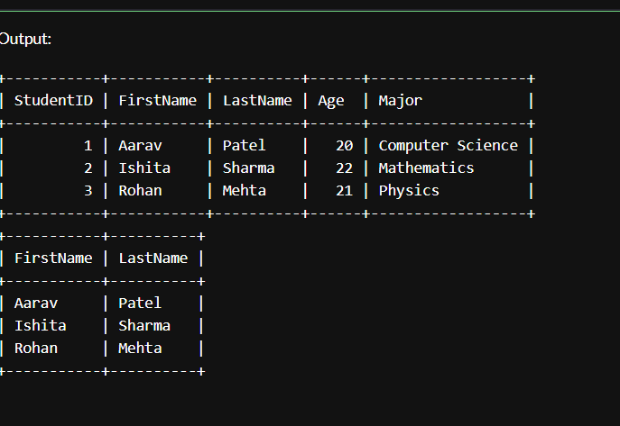

PROGRAM NO.03

Create a table with columns for EmployeeID, Name, Salary, JoiningDate, and
ActiveStatus using different data types. Insert sample data and perform queries to
manipulate and retrieve data.

CREATE TABLE employee (
EmployeeID INT PRIMARY KEY AUTO_INCREMENT,
Name VARCHAR(100) NOT NULL,
Salary DECIMAL(10, 2),
JoiningDate DATE,
ActiveStatus BOOLEAN
);

INSERT INTO employee (Name, Salary, JoiningDate, ActiveStatus) VALUES
('Sarthak Sandhan, 75000.00, '2022-08-01', TRUE),
('Smith Marky', 68000.50, '2021-06-15', TRUE),
('John Doe', 54000.75, '2020-03-20', FALSE),
('Ashish Gaikwad', 82000.00, '2019-11-10', TRUE);

UPDATE employee SET Salary = 79000.00 WHERE Name = Sarthak Sandhan';

DELETE FROM employee WHERE Name = 'John Doe';

SELECT * FROM employee;

SELECT * FROM employee WHERE ActiveStatus = TRUE;

SELECT * FROM employee WHERE JoiningDate > '2021-01-01';

CREATE TABLE department (
dept_id INT PRIMARY KEY,
dept_name VARCHAR(50) UNIQUE
);
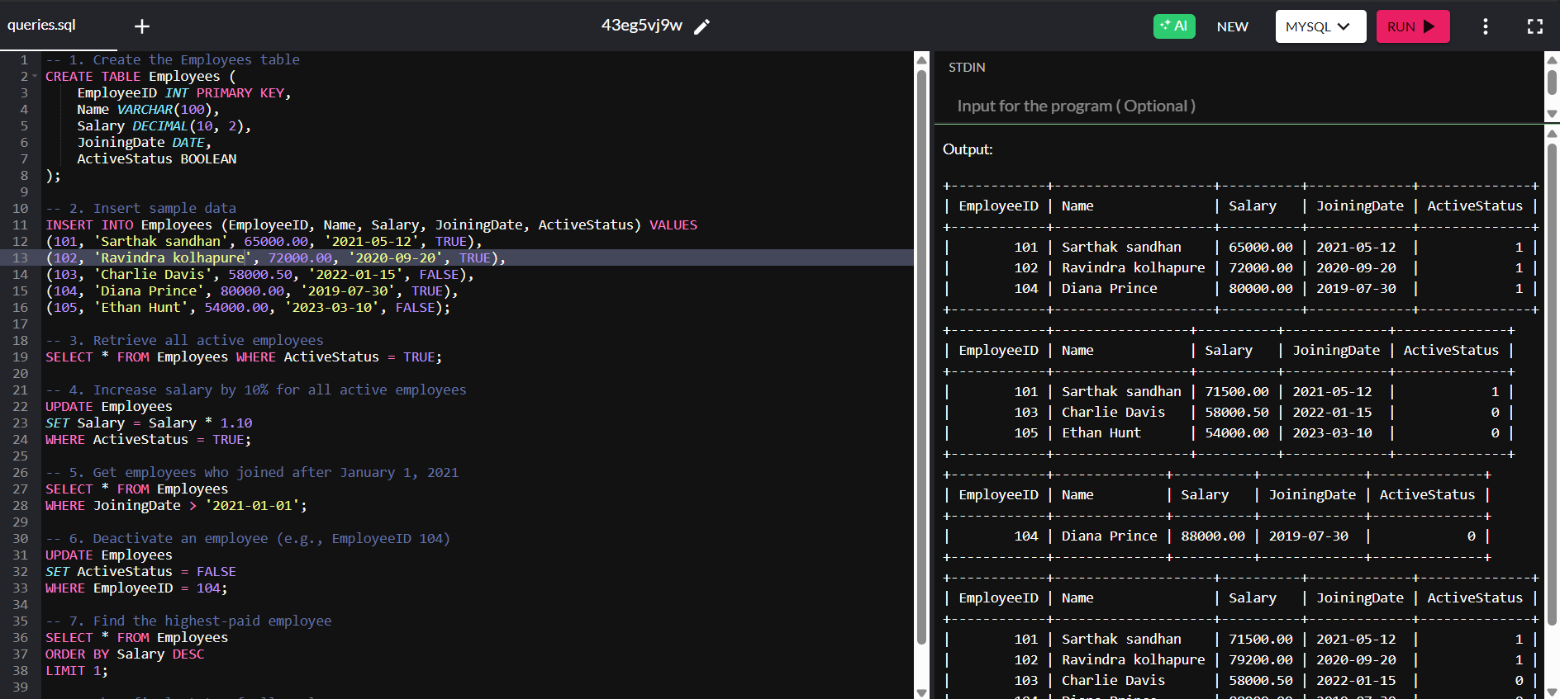

PROGRAM NO.04
Creating Employee Table with Constraints
Aim: Create a table to store employee information with constraints like Primary Key, Foreign Key, and Unique.
CREATE TABLE department (
dept_id INT PRIMARY KEY,
dept_name VARCHAR(50) UNIQUE
);
CREATE TABLE employee (
emp_id INT PRIMARY KEY,
emp_name VARCHAR(50),
email VARCHAR(100) UNIQUE,
dept_id INT,
FOREIGN KEY (dept_id) REFERENCES department(dept_id)
);

INSERT INTO department VALUES (1, 'HR');
INSERT INTO department VALUES (2, 'IT');

INSERT INTO employee VALUES (101, 'Bhakti', 'bhakti@example.com', 1);
INSERT INTO employee VALUES (102, 'Ashish', 'ashish@example.com', 2);
SELECT * FROM department;
SELECT * FROM employee;

-- Invalid Data Tests (Uncomment one by one to test)
-- Duplicate Primary Key (emp_id = 101 already exists)
-- INSERT INTO employee VALUES (101, 'Sahil', 'sahil@example.com', 1);

-- Duplicate Unique email (email = 'bhakti@example.com' already used)
-- INSERT INTO employee VALUES (103, 'Aman', 'bhakti@example.com', 1);
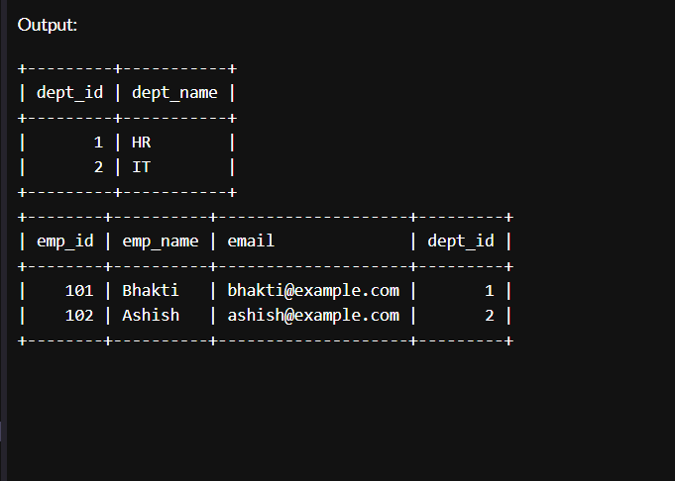
-- Invalid Foreign Key (dept_id = 5 does not exist)
-- INSERT INTO employee VALUES (104, 'Meera', 'meera@example.com', 5);

PROGRAM NO.05
Testing Employee Constraints
Aim: To test constraints like PRIMARY KEY, UNIQUE, and CHECK by inserting invalid data into the Employee table.
Code:
CREATE TABLE customer (
cust_id INT PRIMARY KEY,
cust_name VARCHAR(50) NOT NULL,
age INT CHECK (age >= 18),
email VARCHAR(100) UNIQUE NOT NULL,
city VARCHAR(50) DEFAULT 'Pune'
);
INSERT INTO customer VALUES (1, 'Sarthak', 20, 'sarthak@example.com', 'Delhi');
INSERT INTO customer (cust_id, cust_name, age, email)
VALUES (2, 'Ravi', 25, 'Ravi@example.com');

SELECT * FROM customer;
-- NULL value
-- INSERT INTO customer VALUES (3, NULL, 23, 'nullname@example.com', 'Pune');
-- INSERT INTO customer VALUES (4, 'Tommy', 16, 'tommy@example.com', 'Delhi');

-- Duplicate email
-- INSERT INTO customer VALUES (5, 'Ravi', 30, 'sarthak@example.com', 'Chennai');
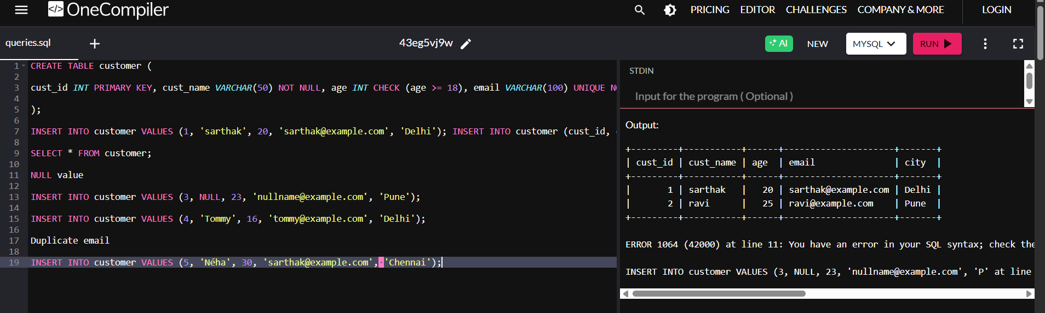

PROGRAM NO.06
Use DDL commands to create tables and DML commands to insert, update & delete
data. Write SELECT queries to retrieve and verify data changes..

CREATE TABLE customers (
cust_id INT PRIMARY KEY,
cust_name VARCHAR(50) NOT NULL,
city VARCHAR(50)
);
CREATE TABLE orders (
order_id INT PRIMARY KEY,
cust_id INT,
product VARCHAR(50),
amount DECIMAL(10, 2),
FOREIGN KEY (cust_id) REFERENCES customers(cust_id) ON DELETE CASCADE
);
INSERT INTO customers VALUES (1, 'Kunal', 'Nashik');
INSERT INTO customers VALUES (2, 'Riya', 'Pune');
INSERT INTO customers VALUES (3, 'Aman', 'Mumbai');

INSERT INTO orders VALUES (101, 1, 'Laptop', 55000.00);
INSERT INTO orders VALUES (102, 2, 'Phone', 20000.00);
INSERT INTO orders VALUES (103, 1, 'Keyboard', 1500.00);

SELECT * FROM customers;
SELECT * FROM orders;
UPDATE customers SET city = 'Aurangabad' WHERE cust_id = 3;
UPDATE orders SET amount = 58000.00 WHERE order_id = 101;
SELECT * FROM customers;
SELECT * FROM orders;
DELETE FROM customers WHERE cust_id = 1;
SELECT * FROM customers;
SELECT * FROM orders; 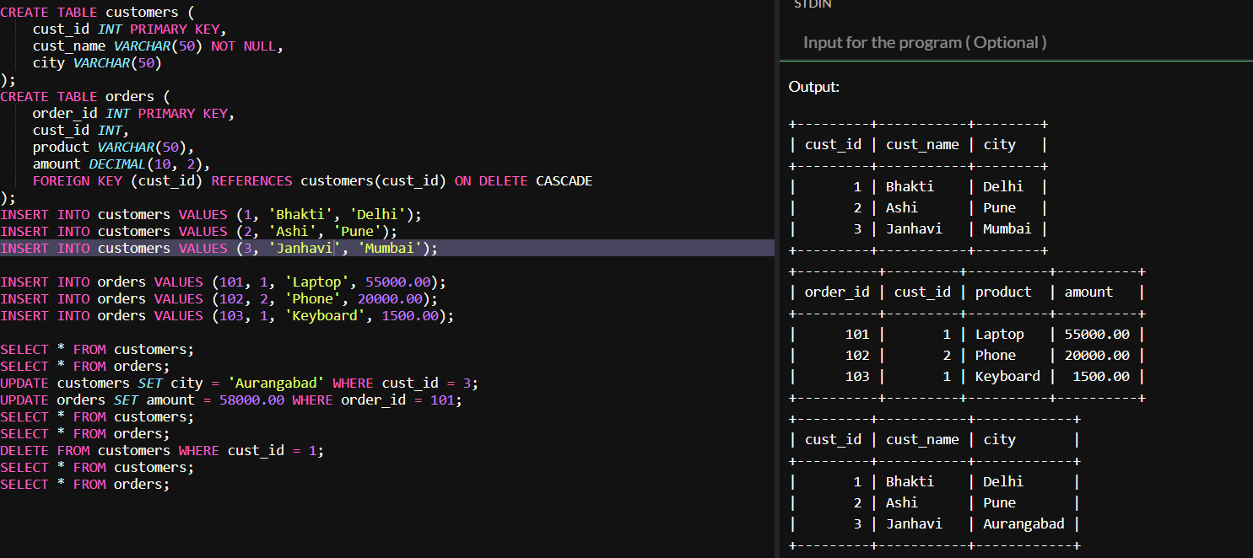
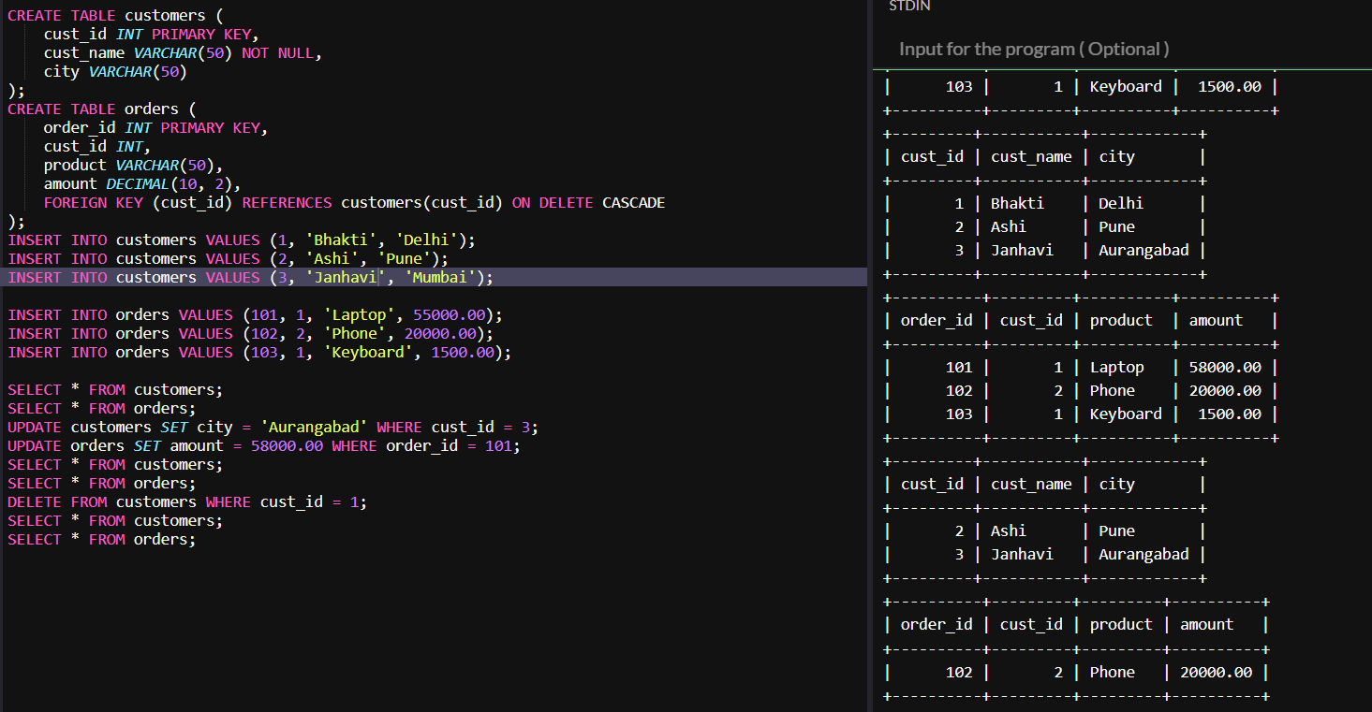

PROGRAM NO.07

7. Create a Sales table and use aggregate functions like COUNT, SUM, AVG, MIN, and
MAX to summarize sales data and calculate statistics.

CREATE TABLE Sales (
SaleID INT PRIMARY KEY,
ProductName VARCHAR(50),
Quantity INT,
Price DECIMAL(10, 2),
SaleDate DATE
);
INSERT INTO Sales VALUES (1, 'Laptop', 2, 60000.00, '2025-04-01');
INSERT INTO Sales VALUES (2, 'Mouse', 5, 500.00, '2025-04-02');
INSERT INTO Sales VALUES (3, 'Keyboard', 3, 1500.00, '2025-04-02');
INSERT INTO Sales VALUES (4, 'Monitor', 1, 12000.00, '2025-04-03');
INSERT INTO Sales VALUES (5, 'Laptop', 1, 60000.00, '2025-04-03');
INSERT INTO Sales VALUES (6, 'Mouse', 10, 500.00, '2025-04-04');

SELECT COUNT(*) AS TotalSales FROM Sales;

SELECT SUM(Quantity * Price) AS TotalRevenue FROM Sales;

SELECT AVG(Price) AS AveragePrice FROM Sales;

SELECT MIN(Price) AS MinimumPrice FROM Sales;

SELECT MAX(Price) AS MaximumPrice FROM Sales;

SELECT ProductName, SUM(Quantity) AS TotalUnitsSold
FROM Sales
GROUP BY ProductName;
SELECT SaleDate, SUM(Quantity * Price) AS Revenue
FROM Sales
GROUP BY SaleDate;
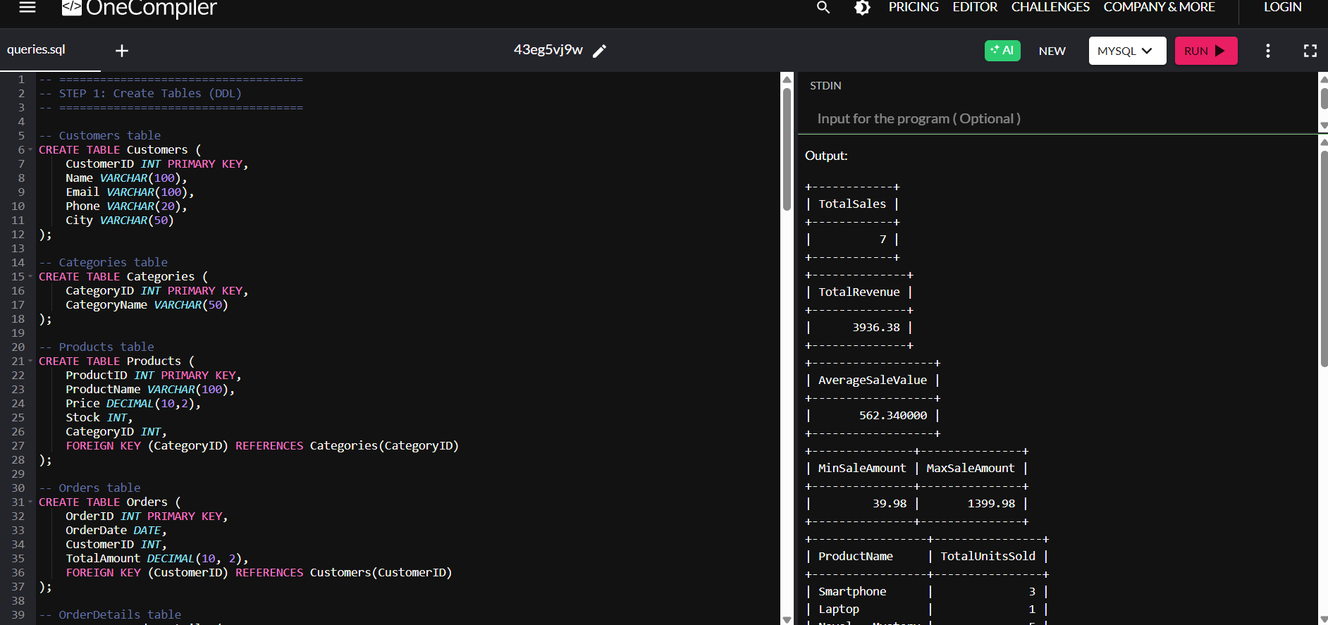
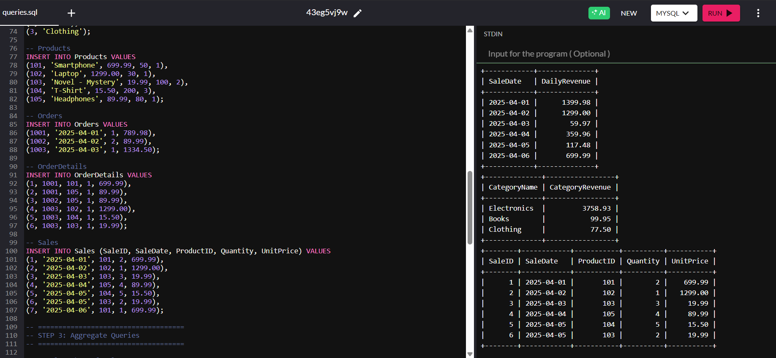

PROGRAM NO.08

Given Customers and Orders tables, write SQL queries to perform INNERJOIN LEFTJOIN, and RIGHTJOIN to retrieve combined data for customer orders..
CREATE TABLE Customers (
CustomerID INT PRIMARY KEY,
Name VARCHAR(50),
City VARCHAR(50)
);
CREATE TABLE Orders (
OrderID INT PRIMARY KEY,
CustomerID INT,
Product VARCHAR(50),
OrderDate DATE,
FOREIGN KEY (CustomerID) REFERENCES Customers(CustomerID)
);
INSERT INTO Customers (CustomerID, Name, City) VALUES
(1, 'Sarthak', 'Delhi'),
(2, 'Ravi', 'Pune'),
(3, 'Priya', 'Nashik'),
(4, 'Aditya', 'Nagpur');
INSERT INTO Orders (OrderID, CustomerID, Product, OrderDate) VALUES
(101, 1, 'Laptop', '2025-02-01'),
(102, 2, 'Mobile', '2025-02-03'),
(103, 1, 'Tablet', '2025-02-04'),
(104, 3, 'Headphones', '2025-02-05');
SELECT Customers.CustomerID, Name, City, Product, OrderDate
FROM Customers
INNER JOIN Orders ON Customers.CustomerID = Orders.CustomerID;
SELECT Customers.CustomerID, Name, City, Product, OrderDate
FROM Customers
LEFT JOIN Orders ON Customers.CustomerID = Orders.CustomerID;
SELECT Customers.CustomerID, Name, City, Product, OrderDate
FROM Customers
RIGHT JOIN Orders ON Customers.CustomerID = Orders.CustomerID;
SELECT * FROM Customers;
SELECT * FROM Orders;
